Key outcome name: Groundwater storage

Authors: James Gilbert^{1,2*}, Dino Bellugi³, Abhinav Sharma¹, Khandaker Iftikhar Islam¹

*Corresponding author: James Gilbert, james.gilbert@ucsc.edu

¹ University of California, Santa Cruz, Institute of Marine Sciences’ Fisheries Collaborative Program, 1156 High Street, Santa Cruz, California 95064, U.S.A.
² Fisheries Ecology Division, Southwest Fisheries Science Center, National Marine Fisheries Service, National Oceanic and Atmospheric Administration, 110 McAllister Way, Santa Cruz, California, 95060, U.S.A.
³ University of California, Berkeley, Department of Environmental Science, Policy and Management, 130 Mulford Hall #3114, Berkeley, CA 94720-3114

Background
The aquifers that underlie the Central Valley provide a source of water to complement surface water for irrigation and municipal use. Pumping of groundwater in excess of recharge rates (the rate at which water enters aquifers) can lead to long-term decline of groundwater storage, increasing risk for reduced groundwater availability (e.g. dry wells) or other undesired outcomes (e.g. subsidence, loss of groundwater contributions to rivers). Groundwater conditions are inherently linked to surface water operations: surface water deliveries can supplant or reduce groundwater pumping and even enhance recharge; under conditions of limited surface water delivery (either from drought or lack of conveyance to a particular area), an increased reliance on groundwater pumping can lead to significant drawdown in groundwater levels. Quantifying how long-term groundwater storage responds to water management actions throughout the Central Valley is important for establishing a complete picture of the water supply conditions across surface and groundwater domains.
Groundwater levels, as recorded in observation wells, are point measures of how much water is in an aquifer. The term groundwater storage, as used here, represents the water stored in an aquifer over a region, not just a point. Regional groundwater storage and point-scale groundwater levels are related – often a decline in storage across an area is accompanied by a drop in water levels in wells. Groundwater storage is naturally spatially-variable due to variation in aquifer characteristics, recharge pathways, and hydroclimate conditions. Groundwater storage variability can be enhanced by water management operations as well. The C2VSIM model linked to CalSim3, like many other groundwater models, captures this spatial variability via simulation of groundwater levels and storage at nodes and elements that make up the Central Valley model domain. The elements provide a local (approximately 30-50 km²) estimate of groundwater storage while “subregion” aggregations of model elements represent the total storage over areas more directly relevant to water management. We use simulated groundwater conditions over these subregions as the basis for assessing changes in groundwater storage.
Groundwater levels and aquifer storage also vary through time, often evolving relatively slowly in response to the cumulative balance (or imbalance) of recharge and extraction occurring in a region. Unlike the Central Valley surface water system, in which reservoir storage can be effectively re-filled or emptied in one or two years, groundwater storage in many areas is characterized by trends best measured over periods of several decades. For this reason, the groundwater key outcome metrics are based on long-term trends in groundwater storage, determined through a linear regression of subregional groundwater storage over time, rather than an evaluation of storage in individual years. For a discussion of how these metrics and calculations relate to California’s Sustainable Groundwater Management Act, please see appendix S-1.
We use three general assertions to distinguish categories of simulated groundwater storage behavior and to guide the assignment of “good” and “bad” indicators (the outcome level values) to each of these categories. The first is that long-term downward groundwater storage trends are undesirable, primarily because they reflect a systematic and consistent imbalance between the use and replenishment of groundwater. The specification of long-term here is intended to capture multi-decadal changes rather than those that occur on a more episodic basis (e.g. during droughts). A second, complementary, assertion is that stable or increasing groundwater storage is a beneficial outcome with respect to the groundwater domain as this represents a condition in which groundwater use is in balance with rates of recharge. These two concepts are illustrated in the colored lines in Figure 1. The red and orange lines show what a long-term decline might look like over a multi-decadal reference period: groundwater storage levels may increase and fluctuate over short time periods, but over the longer term the trend is noticeably downward. The light blue line shows what a stable groundwater storage condition might look like - essentially oscillating around a constant level. The dark blue line shows what a long-term increase in groundwater storage might look like.
The third assertion we rely on for outcome level assignment is that comparison to reference conditions (e.g. recent historical or baseline groundwater storage trends) provides an additional measure by which to gauge groundwater conditions. This connects the evaluation to the current reality (or at least a simulated approximation thereof) rather than absolute thresholds and levels. Inherent in this is the idea that moderation of historical downward trends in groundwater storage is a step toward improvement and that this improvement should be credited as part of the outcome level evaluation. This concept is illustrated in Figure 2, where the dashed and solid lines show a simplified version of a relatively common situation: baseline groundwater storage (solid line) has a downward trend and an alternative scenario being evaluated (dashed line) has a less severe, but nonetheless downward trend as well.
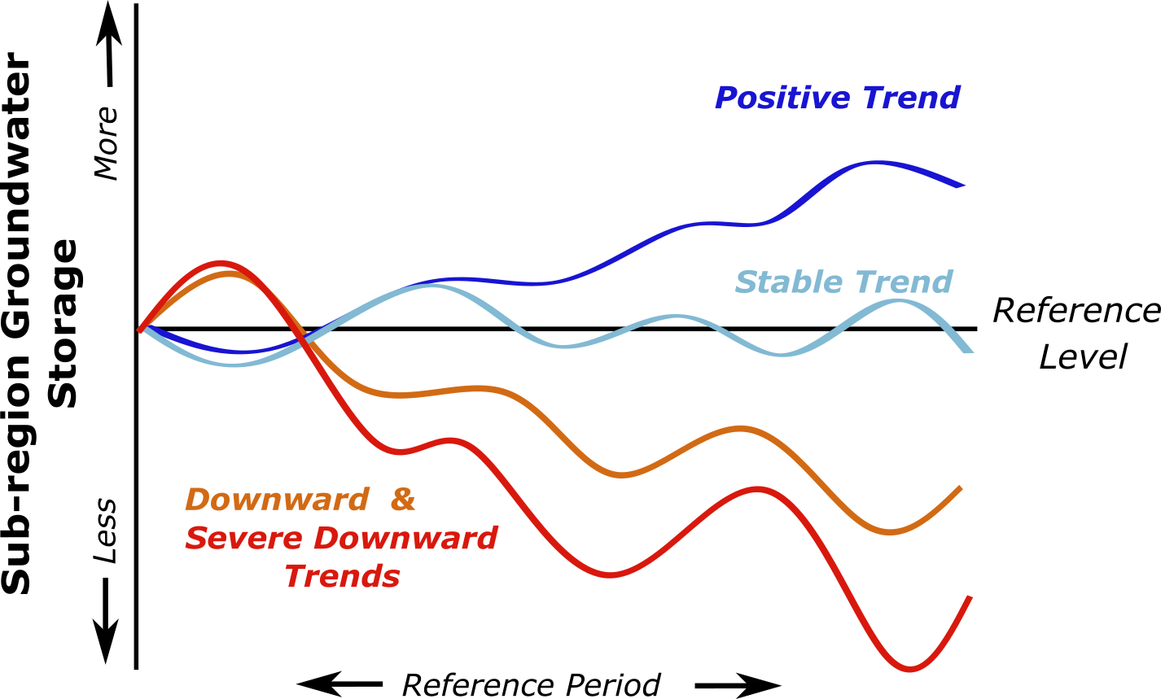
Figure 1. Illustration of different long-term regional groundwater storage trend types that underlie the assignment of outcome level values. The x-axis represents a perfectly stable (constant) groundwater storage condition. All trends are evaluated over a reference period - in this case a multi-decadal period sufficient to capture long-term trends rather than shorter fluctuations that may exist.
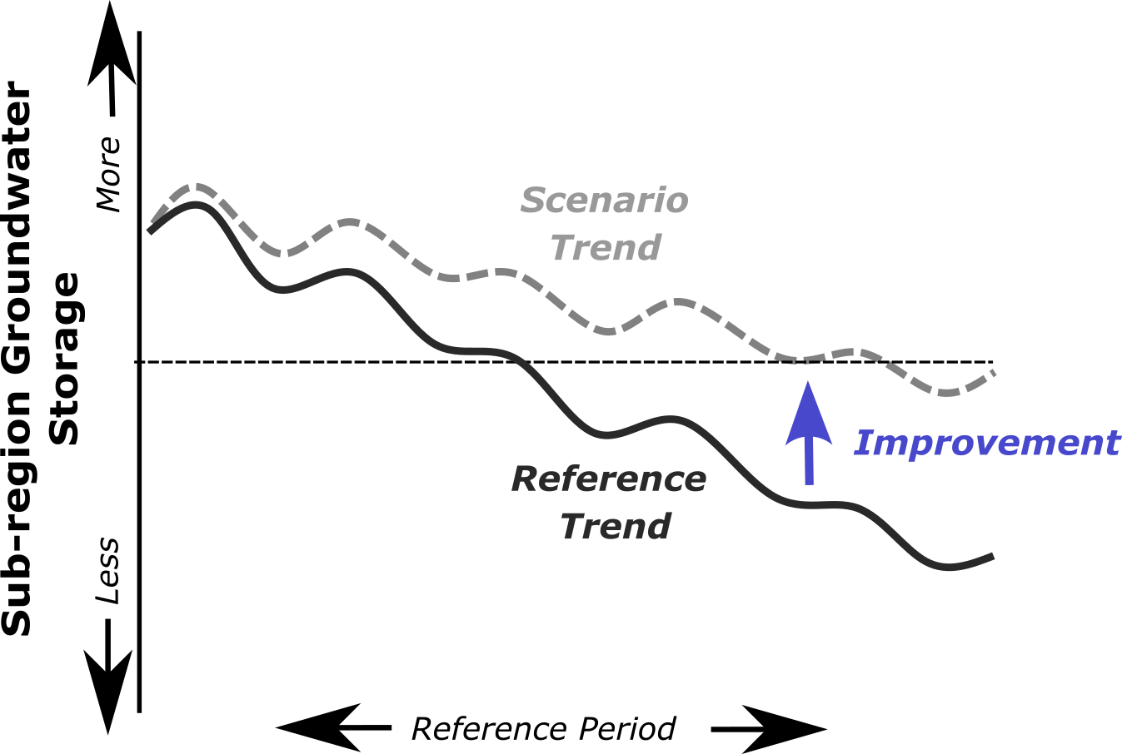
Figure 2. Illustration of a comparison of simulated groundwater storage under an alternative (dashed gray line labeled “Scenario Trend”) to a reference storage trend (black line labeled Reference Trend). In the situation illustrated, both trends are negative in the long term, but the scenario alternative is less negative, representing an improvement relative to the reference conditions. The possibility for such improvement is incorporated in the outcome level designation logic.

Locations of Interest
The subregions defined for the CalSim3 linked groundwater model correspond to the set of elements within or overlapped by CalSim3 Water Budget Areas (WBAs). Each WBA represents a portion of the Central Valley floor with similar landscape, water source, and hydroclimatic characteristics. WBAs are composed of multiple smaller Demand Units that define specific water use and administrative areas. More detailed information on each WBA can be found in the CalSim3 report (Yin et al., 2022). A listing of the groundwater subregions and their corresponding WBA identifier is provided in Table 1. A map of the WBAs is shown in Figure 3.
Table 1. Listing of Water Budget Areas (WBA) and corresponding groundwater model subregions for which a groundwater storage metric and outcome level are calculated.
Water Budget Area (WBA) Identifier | Groundwater Model Subregion ID | Basin | Water Budget Area (WBA) Identifier | Groundwater Model Subregion ID | Basin
02 | 1 | Sac | 19 | 22 | Sac
03 | 2 | Sac | 20 | 23 | Sac
04 | 3 | Sac | 21 | 24 | Sac
05 | 4 | Sac | 22 | 25 | Sac
06 | 5 | Sac | 23 | 26 | Sac
07N | 6 | Sac | 24 | 27 | Sac
07S | 7 | Sac | 25 | 28 | Sac
08N | 8 | Sac | 26N | 29 | Sac
08S | 9 | Sac | 26S | 30 | Sac
09 | 10 | Sac | 50 | 31 | Delta
10 | 11 | Sac | 60N | 32 | SJR
11 | 12 | Sac | 60S | 33 | SJR
12 | 13 | Sac | 61 | 34 | SJR
13 | 14 | Sac | 62 | 35 | SJR
14 | 15 | Sac | 63 | 36 | SJR
15N | 16 | Sac | 64 | 37 | SJR
15S | 17 | Sac | 71 | 38 | SJR
16 | 18 | Sac | 72 | 39 | SJR
17N | 19 | Sac | 73 | 40 | SJR
17S | 20 | Sac | 90 | 41 | Tulare
18 | 21 | Sac | DETAW | 42 | Delta
Basins: Sac = Sacramento River; SJR = San Joaquin River; Delta = Delta and Eastside streams; Tulare = Tulare basin
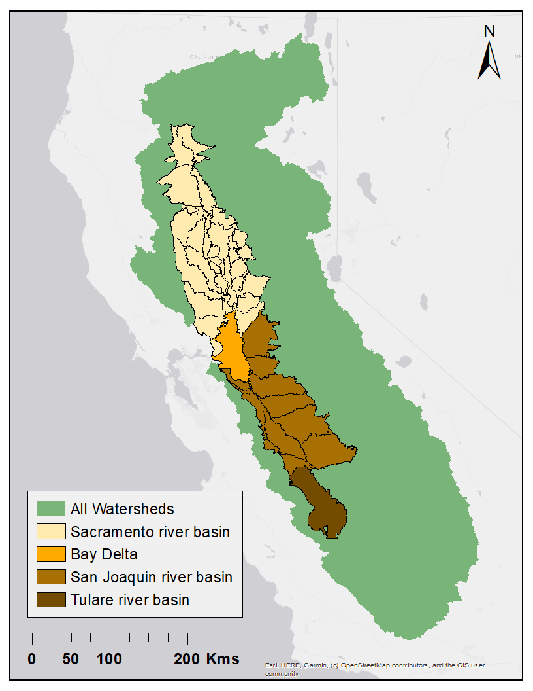
Figure 3. Map of Water Budget Area (WBA) boundaries within the Central Valley, colored in shades of brown by basin. Each WBA corresponds to a groundwater model subregion over which groundwater metrics are calculated.

The CalSim3-linked groundwater model includes three layers of varying thickness and elevations that represent different aquifer systems at depth in the Central Valley. For purposes of this analysis, we consider all three layers that exist within a WBA boundary, summing the storage in each for a total subregional storage value.

Methodology
Groundwater outcome levels are assigned to each WBA based on each scenario’s groundwater storage trend (slope) relative to two reference points: the baseline scenario trend and a severe decline threshold. The baseline trend is determined from a CalSim3 simulation using adjusted historical hydrology as provided by DWR as part of their 2023 Delivery Capability Report (DWR identifier: DCR2023_9.3.1_danube_adj; COEQWAL identifier: s0002). This scenario is similar to the COEQWAL baseline (s0020_DCRadjBL_2020LU_wTUCP; COEQWAL identifier: s0020). The baseline trend is set using a separate scenario from the baselines in the COEQWAL catalog to ensure that a valid tier evaluation can be performed for each scenario.
Groundwater storage data are written to two output files in the DSS format as a standard output of each CalSim3 simulation. We use the data written to the file named GroundwaterOut.dss - this contains “subregion” groundwater storage time series for each month of the simulation for each WBA. We identify the WBA corresponding to the subregion indicators (used in the DSS path names) from the listing in the CalSim3GWregionIndex.wresl file included in each CalSim3 simulation. The groundwater storage time series for each WBA are extracted from the DSS file and written to a CSV file using a batch process written in Python. This CSV file is then re-read by a separate Python notebook that performs several pre-processing steps before the outcome levels are assigned.
The pre-processing involves unit and dimension conversions, data filtering, and trend fitting. The first step sums the groundwater storage over all three aquifer layers represented in the coupled C2VSim model to yield a total WBA-level groundwater storage time series. This volume is then converted to an equivalent depth, in units of feet, by dividing by the surface area of the WBA (e.g. volume = 5 million acre-feet; area = 1 million acres; equivalent depth = volume/area = 5 million acre-feet/1 million acres = 5 ft). Note that this depth value represents an area-averaged estimate of the groundwater available in aquifers beneath a particular WBA, not a depth to groundwater. Additional preprocessing steps filter the time series to the 1960-2021 time period to better represent the underlying response of the groundwater system when coupled with the surface system. Including the entire simulation period (1921-2021) incorporates large changes (mostly sharp declines) in groundwater storage that occur in many subregions in the first few years of the simulation. We suspect these large declines are the result, at least in part, of the equilibration from a mis-matched local initial condition because the groundwater storage behavior after the first ~20 years of simulation reacts in a fundamentally different manner after these initial shifts.

Discrete key outcome levels
Discrete outcome levels first classify scenarios into broad performance categories based on the groundwater storage trend in each WBA:
- Level 1: the slope is positive and equal to or greater than the baseline reference
- Level 2: scenarios with a slope that is positive but less than the baseline reference (as long as the baseline is also positive) are assigned to Level 2
- Level 3: scenarios with moderate negative trends are assigned to Level 3, and
- Level 4: scenarios exceeding the severe decline threshold are assigned to Level 4.

The baseline scenario itself is assigned Level 0 as a reference case, although it is ultimately dropped from the final results.

The key outcomes from the outcome level calculation process are assignments of an integer value (1,2,3, or 4) to each WBA in the CalSim3 model domain. An outcome level value closer to 1 represents conditions with increasing groundwater storage while larger numerical values represent incrementally declining groundwater storage. A brief interpretation of each outcome level is provided in Table 2 below.

Table 2. Trend-based rules and interpretation for groundwater storage outcome levels.
Outcome level | Threshold | Interpretation
1 | Positive slope AND higher than baseline slope | Rising groundwater levels, more groundwater storage than current conditions
2 | Positive slope AND lower than baseline slope | Rising groundwater levels but not as much groundwater storage as current conditions
3 | Negative slope; Slope > -0.015 ft/yr | Moderate long-term groundwater decline
4 | Negative slope; Slope < -0.015 ft/yr | Severe long-term groundwater decline

Continuous key outcome level
Continuous outcome level values are assigned using a progress metric calculated to locate each scenario within its discrete outcome level interval. This progress value represents the scenario’s relative position between the upper and lower performance boundaries of that outcome level. Continuous outcome levels are then expressed as:
- 1.00–1.99 for Level 1
- 2.00–2.99 for Level 2
- 3.00–3.99 for Level 3
- 4.00–4.99 for Level 4

Lower continuous values indicate stronger performance within an outcome level, while higher values indicate weaker performance and proximity to the next worse outcome level. The continuous values are calculated to ensure consistency with the discrete integer outcome level values (e.g. an outcome level continuous value of 2.78 corresponds to the discrete value Level 2). For Level 1 and Level 2, progress is determined by comparing positive groundwater recovery trends to the baseline slope, measuring how far performance departs from baseline conditions. For Level 3, progress is based on how close a negative slope is to the severe decline threshold. For Level 4, progress measures the extent to which groundwater decline exceeds this threshold, indicating increasingly severe overdraft conditions. This interpolation preserves the discrete classification while providing finer resolution for comparing scenarios within the same groundwater performance category.
Discrete outcome level value assignment is implemented with an if/elseif/else approach. To obtain continuous values that differentiate within the outcome levels (e,g. how close is a Level 2 assignment to Level 1 or 3), the ratio of the two slopes is examined.
The continuous value of a Level 1 assignment is given by (a) when the baseline has a positive slope or (b) when the baseline slope is negative
- Level 1 (continuous) = 1.0 + (baseline_slope / slope)
- Level 1 (continuous) = 1.0 + abs(baseline_slope)/(abs(baseline_slope)-baseline_slope +slope)
For Level 2 the ratio is inverted, and the formula becomes:
(c ) Level 2 (continuous) = 2.0 + (1.0 - (slope / baseline_slope))
Level 3 follows the same formulation as Level 2, but the slope is compared to the severe decline threshold instead of the baseline slope and the formula becomes
(d) Level 3 (continuous) = 3 + (slope / severe_decline_threshold)
In the case of Level 4, the ratio is inverted, but as it is not strictly bounded by 5, the result is clipped to remain within the 4-5 interval, and the formula becomes
(e) Level 4 (continuous) = min(4.999, 4 + (1 - (severe_decline_threshold / slope)))
The result is a continuous variation that remains within the outcome level boundaries (and thus collapses to the discrete outcome level when the floor of the value is computed).
The severe decline threshold was set at -0.015 ft/yr based on a review of the distribution of long-term decline values in the baseline reference scenario (s0002).
Pseudocode that summarizes the groundwater outcome level assignment procedure can be found in Appendix S-2. The Python source code used to calculate the groundwater outcome levels is available as part of a larger GitHub repository developed for processing CalSim data for COEQWAL: https://github.com/canruso/COEQWAL_V3. The functions for extracting and processing the groundwater storage data is available in the file tier.py. The workflow for calculating the outcome level values based on the processed data is contained in the notebook Tier_Assignment_Groundwater.ipynb.
The map in Figure 4 shows an example of the groundwater storage discrete outcome level results for scenario 20, a baseline reference scenario. The WBA polygons (corresponding to the groundwater subregions over which the storage data is summarized) are colored according to the discrete outcome level value determined using the methods described above. Yellow and red polygons indicate areas where groundwater levels are in decline, primarily in the southern San Joaquin valley. This is consistent with observed conditions in that region. Conversely, blue and green polygons over much of the rest of the domain indicate groundwater storage is relatively stable or increasing.
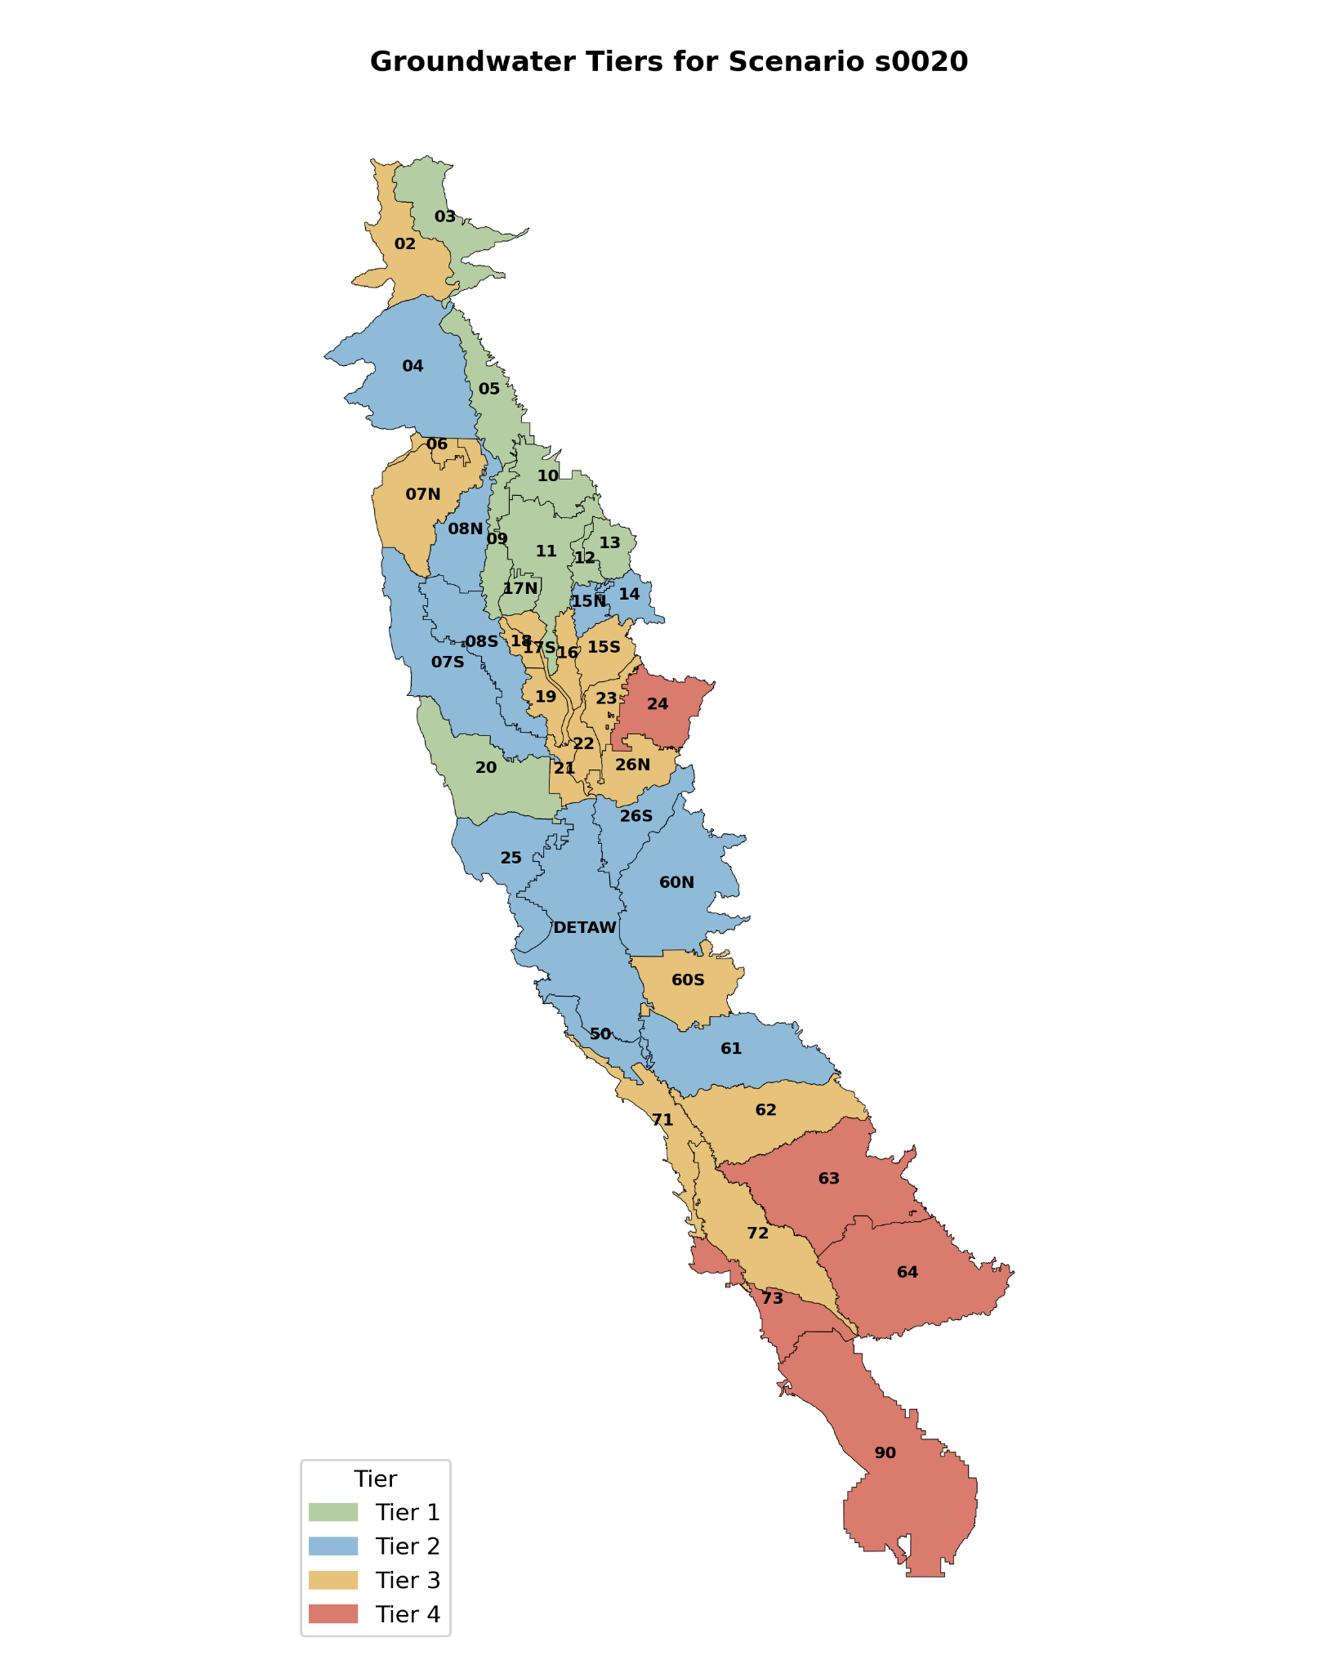
Figure 2. Example groundwater outcome level results displayed as a map of Water Budget Area (WBA) colored by discrete outcome level value for scenario 20 (a baseline reference scenario).

Guidelines for Interpretation
The outcome level framework described here provides an indicator of long-term groundwater storage conditions over the CalSim3 domain in a way that simplifies the complex and voluminous groundwater simulation results created for each scenario. This simplification introduces some limitations in the representation of spatial and temporal details of groundwater response across the Central Valley. Depending on one’s specific interests with regards to groundwater conditions, the outcome level results may not be a universally suitable metric by which to judge scenario outcomes.

Outcome levels are not suitable for evaluating local conditions
One key consideration is that the reliance on a subregion-averaged groundwater storage obscures local scale variations. Over some of the larger WBAs/subregions that may experience heterogeneous or clustered groundwater pumping, there may be areas with meaningful groundwater decline that, when averaged with areas experiencing less decline (or increases), yield an outcome level value with less severity than the local conditions might suggest. It is also important to note that the underlying C2VSim groundwater model used in this analysis is itself a coarse resolution that provides only an approximation of local groundwater levels.

Outcome levels are not suitable for evaluating groundwater conditions in certain periods or over short time intervals
As noted in the methods section, the simulated groundwater storage data used for trend-fitting is clipped to the 1960-2021 period to avoid including potentially anomalous initial declines in storage. Including the full time period in the outcome level calculation would change the results for some WBAs from a Level 1 or 2 condition toward a Level 3 or 4 simply because of the scale of the groundwater storage decline in the first few years of simulation, despite the groundwater storage behavior reflecting stable or even improving conditions in the remaining portion of the simulation. In cases where groundwater decline continues for much of the simulation, this clipping of the time series is less impactful on the outcome level result as a trend fitted to a monotonically decreasing series will yield a Level 3 or Level 4 result regardless. The linear trend fitted to each time series is meant to identify the core long-term balance of inflows (recharge) and outflows (pumping) in the aquifer system, but will not provide information about short term variation driven by sequences of wet and dry years. The outcome level value, therefore, will not provide a meaningful measure of the groundwater response to a single drought event. Instead, it will represent the cumulative effects of many such events as they occur between wetter years in the hydrologic record.

Outcome level results do not necessarily translate to specific quantitative real-world groundwater levels
The outcome level values summarize the results of a numerical groundwater model. As a simplification of reality itself, the results of this model may not precisely match observed groundwater conditions in all locations across the Central Valley. While the outcome level framework was designed with the goal of minimizing the effect of model-observation mismatches, it is worth noting that an outcome level designation does not necessarily translate directly to, suggest, or guarantee a quantitative groundwater level outcome such as a water table depth in a specific location or an estimate of the number of wells that would go dry in a region. As an illustration, consider a WBA that has a Level 1 designation for a certain scenario. This would be interpreted as indicating that groundwater levels under that scenario tend to be stable or increasing - a generally good thing for the long-term sustainability of the groundwater resource in that area. If the model has a bias that causes simulated groundwater levels to be 20 feet higher than what is measured in observation wells, and that 20-ft difference overlaps with the completion depth for some drinking water or supply wells, it becomes evident that the model cannot provide an accurate assessment of whether those drinking water wells will (or won’t) go dry in that scenario.

Additional caveats
There are some more specific limits or caveats to keep in mind when interpreting the groundwater outcome level results. First, the continuous outcome level values should be viewed as gradations between categories, with boundaries being the integer values greater and less than the decimal value. However, the numerical value does not universally indicate a linear distance between bounding integer outcome level values. For example, an outcome level value of 1.58 could be interpreted as being roughly midway between Level 1 and Level 2, but is not strictly mathematically 58% between Level 1 and Level 2 as the theoretical best Level 1 condition can only be approached asymptotically. Similarly, the worst Level 4 continuous value is technically unbounded, although we clip the values to 4.999 for practical purposes.
The framework does allow some rare edge cases that could produce somewhat anomalous results. For example, if the baseline slope is negative but the scenario slope is positive (a not infrequent occurrence), the categorical outcome level designation is 1 but the continuous value is calculated in a different way to account for the negative baseline slope. If the difference between the scenario and baseline slope is exactly symmetrical about 0 (e.g. baseline slope = -0.01 and scenario slope is +0.01), the resulting outcome level value will always be 1.33, regardless of how positive the scenario slope is. We did not encounter this exact situation in the more than 140 scenarios analyzed, but it is a theoretical possibility to be aware of.
Finally, setting the dividing line between ‘moderate’ and ‘severe’ groundwater storage decline requires some modeler judgement and may affect the distribution of Level 3 and Level 4 conditions. We relied on an analysis of the distribution of long-term groundwater trends to identify a sensible break point between more common groundwater drawdown and more extreme conditions. We applied this threshold model-wide, acknowledging that in some cases local conditions or analytical purposes may warrant a different threshold.

References

Brush, C. F., Dogrul, E. C., & Kadir, T. N. (2016). Development and Calibration of the California Central Valley Groundwater-Surface Water Simulation Model (C2VSim), Version 3.02-CG (DWR Technical Memorandum No. v1.1 3/2016). Sacramento, CA: California Department of Water Resources. Retrieved from https://data.cnra.ca.gov/dataset/c2vsimcg_r374_rev/resource/9686ebb0-158b-4dbf-92e7-686c5bd5b8b3

Dogrul, E. C., Kadir, T. N., Brush, C. F., & Chung, F. I. (2016). Linking groundwater simulation and reservoir system analysis models: The case for California’s Central Valley. Environmental Modelling & Software, 77, 168–182. https://doi.org/10.1016/j.envsoft.2015.12.006

Yin, H., Chen, Z., Dogrul, E. C., Hillaire, T., Lui, M. (Idy), Polsinelli, J., et al. (2022). CalSim 3 Report: A Water Resources System Planning Model for State Water Project & Central Valley Project (p. 776). Sacramento, CA: California Department of Water Resources. Retrieved from https://data.cnra.ca.gov/dataset/calsim-3-0-release/resource/2d4160d7-cbe1-4e63-8cdd-98f322e74cf2

Code Repository: https://github.com/canruso/COEQWAL_V3

Appendix

Appendix S-1. Relationship of key outcome levels to California’s Sustainable Groundwater Management Act.
Our goal in formulating the groundwater outcome level metrics was to provide a quantitative summary of long-term groundwater trends as a proxy for groundwater sustainability. The Sustainable Groundwater Management Act (SGMA) established a process by which local groundwater sustainability agencies must develop and implement sustainability metrics that meet a range of criteria. While these SGMA-derived sustainability metrics would provide a basis for outcome level designation most directly tied to current regulatory conditions, we encountered two key issues that made such an approach difficult to implement within the time constraints of this project. First, at the outset of this effort, we were unable to find a publicly-available and comprehensive database containing all information needed to evaluate SGMA criteria for all locations represented in the CalSim3 simulations. Second, many SGMA criteria rely on comparison to absolute groundwater levels at local scales, as represented by measurements at selected indicator wells. The C2VSim model linked to CalSim3 may not always represent local variation in water levels with sufficient accuracy to ensure that direct use of simulated groundwater levels for the indicator wells is justified. Furthermore, the use of the Calsim3 hydrologic pre-processing and boundary conditions may introduce biases in groundwater response that make a direct comparison inappropriate. Given these challenges, and because CalSim3 is best interpreted from a comparative perspective (i.e. examining the change in results between scenarios rather than the numerical value of a result in a single scenario), we determined that it would be more appropriate to define our measures of groundwater sustainability based on differences relative to a static baseline simulation.

Appendix S-2. Pseudocode for groundwater outcome level assignment.
The groundwater outcome level assignment procedure can be summarized by this pseudocode. As a note, outcome levels are referred to as ‘tiers’ in the pseudocode:

FOR each groundwater subregion (WBA):
Define:
baseline_slope
trend under baseline scenario

severe_decline_threshold
threshold for unacceptable decline (same for all basins)

FOR each scenario:
#--------------------------------------------------
#STEP 1: Assign discrete tier
#--------------------------------------------------
IF data missing:
tier = NaN

ELSE IF scenario is baseline:
tier = 0

ELSE IF slope >= baseline_slope:
discrete tier = 1
#(improving faster than baseline)

ELSE IF slope >= 0:
discrete tier = 2
#(positive trend, but weaker than baseline)

ELSE IF slope >= severe_decline_threshold:
discrete tier = 3
#(declining, but within acceptable range)

ELSE:
discrete tier = 4
# (severe decline)

#--------------------------------------------------
#STEP 2: Compute within-tier progress
#--------------------------------------------------
Progress measures position within the
assigned slope interval.

progress = 0
#strongest point in tier
progress = 1
#weakest point in tier

IF Tier 1:
IF baseline_slope >= 0:
progress = baseline_slope / slope
ELSE:
progress = abs(baseline_slope)/(abs(baseline_slope)-baseline_slope+slope)

# Higher positive slopes produce
# lower continuous values

ELSE IF Tier 2:
progress =
1 - (slope / baseline_slope)

# Measures degradation from baseline
# down to zero trend

ELSE IF Tier 3:
progress =
slope / severe_decline_threshold

# Measures decline from zero trend
# toward severe decline threshold

ELSE (Tier 4):
progress =
1 - (severe_decline_threshold / slope)

#Measures decline beyond the
#severe threshold

--------------------------------------------------
STEP 3: Compute continuous tier
--------------------------------------------------
continuous tier =
discrete tier + progress

The Python source code used to calculate the groundwater outcome levels is available as part of a larger GitHub repository developed for processing CalSim data for COEQWAL: https://github.com/canruso/COEQWAL_V3. The functions for extracting and processing the groundwater storage data is available in the file tier.py. The workflow for calculating the outcome level values based on the processed data is contained in the notebook Tier_Assignment_Groundwater.ipynb.

